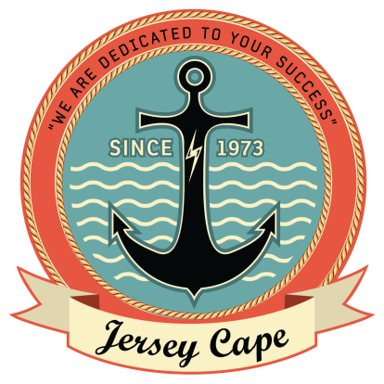
jerseycape.org

Developmental Disabilities Awareness Month
Disability Awareness/People First Language Pledge
I pledge:
- To advocate and accept my responsibility to be respectful to the individuals I work with and for.
- To respect and treat all individuals equally.
- To call each person by their name and refer to them as “individuals/people", and stop using the word “client”.
- To support self-advocacy and stand up for individuals’ human rights.
- To be an advocate for “no more R word” in my workplace and everywhere I go.
- To assist and make sure that each person that I work with can make their own choices, is part of a community of their choice, and feel accepted to be themselves.
- I will use "people first language", which means seeing the person, not the disability, using words and terms that are easier for people to understand.
- To be an ambassador for self-advocates, speak up for people first language, and be the voice for change that makes peoples’ lives happen!
To the best of my ability I solemnly swear to live by this pledge.
Signature__________________________________________________Date______________________

